Credit Name

2140

Credit Assignment

E9 Guessing Game

How has your program changed from planning to coding to now? Please explain?

Beginning the code

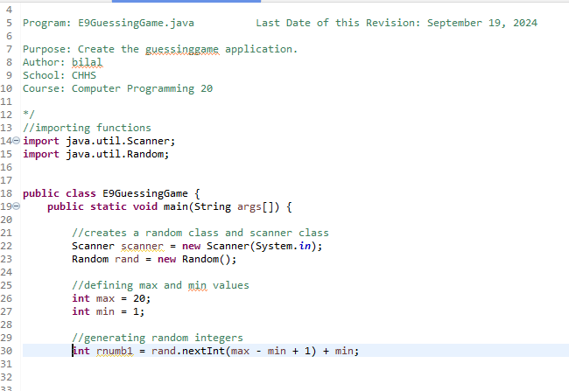

Simply the rest of the code

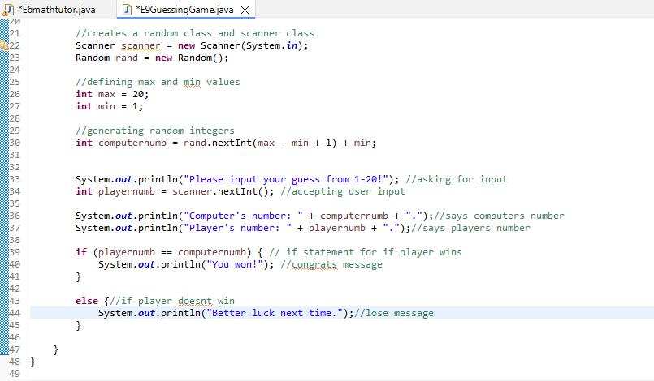

If player puts number above 20 it still works

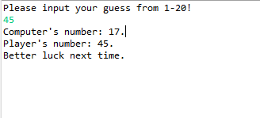

Goingto fix

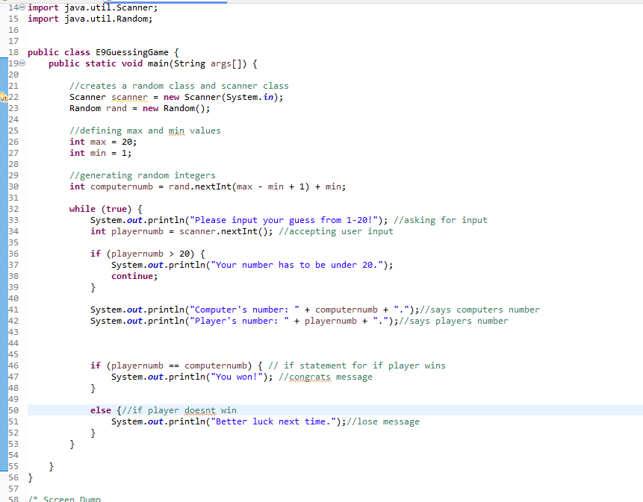added a loop to make it if user puts something higher then 20 it reasks for input

Still need to break loop

Break added

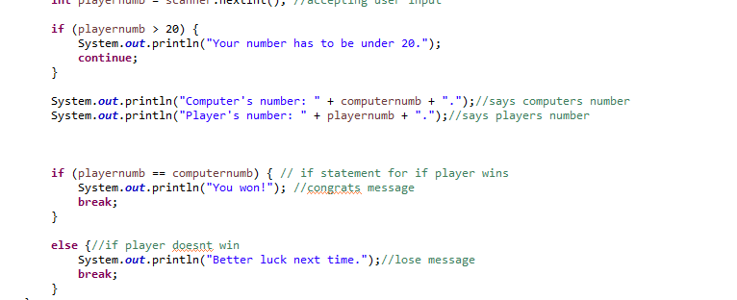

Need to fix comments

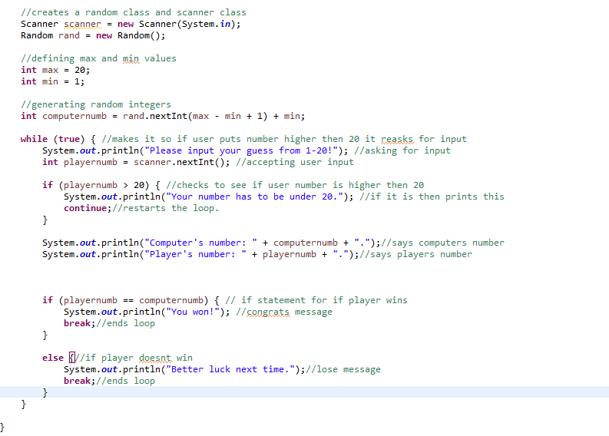

Final code

Going to add cheat code ;)

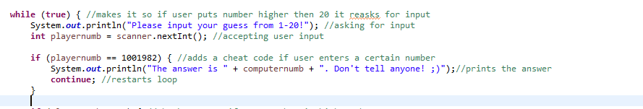

Cheat code added. If you type 1001982 it will print whatever number the computer has generated so you can win!